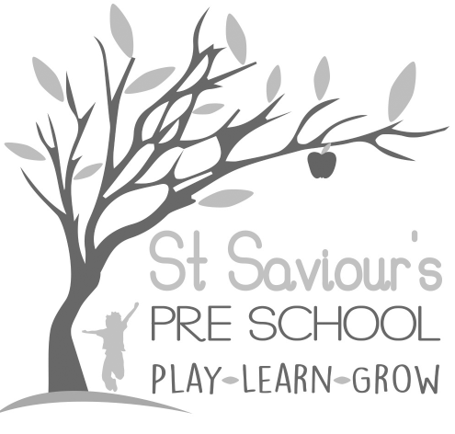

4.0 KEY PERSON

4.1 THE ROLE OF THE KEY PERSON AND SETTLING-IN POLICY

Written by: Claire Toms and Tina Alder Date: 1.09.22. – reviewed 08.10.24.

Policy statement
At St Saviour’s Pre-school and Nursery, we believe that children settle best when they have a key person to relate to, who knows them and their parents well, and who can meet their individual needs. Research shows that a key person approach benefits the child, the parents, the staff, and the setting by providing secure relationships in which children thrive, parents have confidence, staff are committed, and the setting is a happy and dedicated place to attend or work in.
Our aim is for children in our care to feel safe, happy, and stimulated and to feel secure and comfortable with our staff. We also want parents to have confidence in both their children’s well-being and their role as active partners with our setting. We aim to make our setting a welcoming place where children settle quickly and easily because consideration has been given to the individual needs and circumstances of children and their families.
The key person role is set out in the Safeguarding and Welfare Requirements of the Early Years Foundation Stage (EYFS 2025). Each child must have a named key person who is responsible for supporting their emotional well-being, planning for their learning and development, and maintaining close communication with parents. These procedures set out a model for developing a key person approach that promotes effective and positive relationships for children.

Procedures
- Before entry, each child is allocated a key person, and is part of a named group. The key person is made available to the new children to help and support their settling-in period and forms a close relationship with each child in their group, and they get to know each other.
- The key person meets the children and parents at induction sessions and reads the home information sheets. They record details of health needs, interests, comfort strategies, family context, and any SEND needs in the child’s Learning Journal or online profile. This information is taken into account when planning small group activities. Each child’s Learning Journal can be read and contributed to by parents/carers, making it a useful tool of communication.
- The key person records observations of what the child says, how they solve problems, their achievements, ideas, interests, social skills, and any difficulties. This information informs planning, individual next steps, and contributes to statutory assessments, including the 2-year Progress Check and the EYFS Profile (where applicable).
- The key person forms links with other carers involved with the child and coordinates the sharing of appropriate information about the child’s development with those carers.
- They encourage positive relationships between children in their key group, spending time with them as a group each day.
- We promote the role of the key person as the child’s secure base in our setting, and as the foundation for establishing relationships with other adults and children.

Settling
- We provide a safe and happy environment at St Saviour’s, where children feel confident, relaxed, and can develop their full potential. Our priority is to ensure each child settles as quickly as possible.
- Prior to starting, parents/carers are invited to an induction session for their group at Pre-school, so they can talk to their child’s key person and prepare the child at home.
- Each child is allocated a key person who will primarily help to settle that child.
- Parents are consulted about settling-in procedures and a personalised settling plan is agreed to meet the child’s individual needs and family circumstances.

The 2-year Progress Check
- In line with EYFS 2025, a progress check at age two is carried out by the key person, in partnership with parents and other professionals involved with the child.
- The progress check is a review of the child’s learning and development, focusing on the prime areas.
- Within the progress check, the key person will note areas where the child is progressing well and identify areas where progress is less than expected.
- The report is shared with parents and actions to address any concerns are agreed with parents/carers.
- The key person will plan activities to meet the child’s needs within the setting and will support parents to understand the child’s needs to enhance their development at home.
- If necessary, we may seek advice from outside agencies such as the Health Visitor, Speech and Language Therapist, or other appropriate professionals.
- Where a child is identified as needing additional support, this will be aligned with our SEND Policy and the graduated approach set out in the SEND Code of Practice (2015).

Transition to School or Another Setting
- The key person plays a central role in supporting children through transitions, including moving to school, another early years setting, or a new group within the pre-school.
- They liaise with parents/carers and the receiving setting to share information about the child’s learning, development, routines, interests, and any additional needs.
- Transition plans are personalised to ensure continuity of care and learning, helping the child feel secure and confident during the change.
- Where appropriate, children are supported through visits, photographs, or familiarisation sessions, and the key person works closely with families to prepare them for the transition.
- The key person ensures that all relevant documentation, such as Learning Journals, progress checks, and care plans, are up to date and shared with the new setting or school with parental consent.

